Buffalo Mountain Camp – Horseback Letter/Releases

Dear Parent or Guardian of Horseback Campers:

Each morning we will be traveling by van or bus from camp to Jonesborough, to the Millercrest Stables where your camper will receive instruction from Gary Miller and his staff in English Saddle. The stable is independent and non-affiliated with Buffalo Mountain Camp, but is one which we have used now for 15 years and can highly recommend - its quality superb. We believe that this program is safe, and have had no major injuries at the stables since we began our association. However, because it is a horseback program it is important to inform you that there are inherent risks involved. We can assume no liability for accidents or incidents occurring while campers are engaged in horseback riding, beyond our normal health insurance. Nor, can Millercrest Stables.

As Tennessee Law states:

An equine professional is not liable for an injury to or the death of a participant in equine activities resulting from the inherent risks of equine activities, pursuant to Tennessee Code Annotated, Title 44, Chapter 20.

When you bring your child to camp, please bring the two attached release forms. This, along with their signed health form is required before any child is allowed to ride at Millercrest.

Thank you for your attention to this! We are looking forward to your child joining us at Horse Camp. It has become one of our best loved camps!

Sincerely:

Jason Onks
Camp Director

Directions for Camp Closings:

Jr. Horse and Horse I close with a horse show that begins at 10:15 a.m. at Millercrest Stables located on 154 Sunny Acres Road. Go to Jonesborough. At intersection of 11-E and Hwy 354, take Hwy 354 towards Boone’s Creek. A short distance past a pediatric office prepare to turn right onto Forest Dr. take immediate left onto Old Boones Creek Road. The first paved left is Sunny Acres. The phone number is 753-2201. After the horse show, follow the camp van back to camp. We will have a horse camp closing at the fire ring behind Allison Lodge immediately upon the group’s arrival back to camp. Camp ends after lunch, to which you are invited. We will need to know at check-in on Monday how many will plan to stay for Friday’s lunch. If you have other children attending one of our other resident camps, their camps will close at 2:00 p.m.. We ask that you please wait and stay for their programs too.

Horse II – Your closing is from 2:00-2:45 at Buffalo Mountain Camp. Instead of a horse show at Millercrest, if skills progress well, you will have a trail ride on Friday.

MILLERCREST RELEASE

RELEASE OF CLAIMS AND DEMANDS

I, the undersigned, hereby affirm that I have made application to enroll in a course in horseback riding to be held at Millercrest Stables in Jonesborough, TN. By enrolling in this course, I certify that I am cognizant of all the inherent dangers of horseback riding, and of the basic safety rules for activities connected therewith.

I understand and agree that in consideration of allowing me to participate in this instructional course of horseback riding, that Gary Miller d/b/a/ Millercrest Stables, his agents, or his servants may not be held liable in any way for any occurrence in connection with said course which may result in injury, death, or damage to me, or claims or demands by me, my family, my heirs, or assigns.

In further consideration of being allowed to participate in the above mentioned course, I hereby personally assume all risks in connection with said course, and I further release Gary Miller individually and d/b/a/ Millercrest Stables, his agents and servants from any harm, injury or damage with may befall me while I am participating in said course, including all risks connected therewith, whether foreseen or unforeseen; and further to save and hold harmless Gary Miller, individually and d/b/a/ Millercrest Stables, his agents and servants, from any and all claims and demands by me, or my family, estate, heirs, or assigns, arising out of my participation in the above mentioned instructional course in horseback riding notwithstanding the cause or causes of the injury, death or damages, claims, or demands sustained by me.

I further state that I am of lawful age and legally competent to sign this affirmation and release; that I understand that the terms herein are contractual and not a mere recital and that I have signed this document as my own free act.

I have fully informed myself of the contents of this affirmation and release by reading it before I signed it.
In witness thereof, I have executed this affirmation and release on this the_________________________
Day of _____________________________.

Warning:
Under Tennessee Law, an equine professional is not liable for any injury to or the death of a participant in equine activities resulting from the inherent risks of equine activities, pursuant to Tennessee Code Annotated, Title 44 and Chapter 20 (Acts 1992 ch. 974, Section 6).

If students are under the age of eighteen (18) years, this form must be signed by student’s parents or legal guardians.

We the undersigned affirm that we are the parents/ and/or legal guardians of __________________a minor, who has enrolled in a course at Millercrest Stables for the instruction of horseback riding. We further affirm that in consideration of permitting this student to enroll in said class that we have read the above Release of Claims and Demands and hereby sign this instrument for the purposes therein contain ed in said Release of Claims and Demands. We also agree that in further consideration for permitting our minor son, daughter, or ward, to enroll in the above mentioned class that we will indemnify Gary Miller d/b/a/ Millercrest Stables for any and all claims, suits, actions, debts, damages, costs, charges, and expenses including court cost and attorneys fees and against all liability, losses and damages of any nature whatever, that Gary Miller d/b/a/ Millercrest Stables shall or may at any time sustain participation in the course mentioned above.

________________________________ ______________________________

________________________________ ______________________________
Relationship Relationship

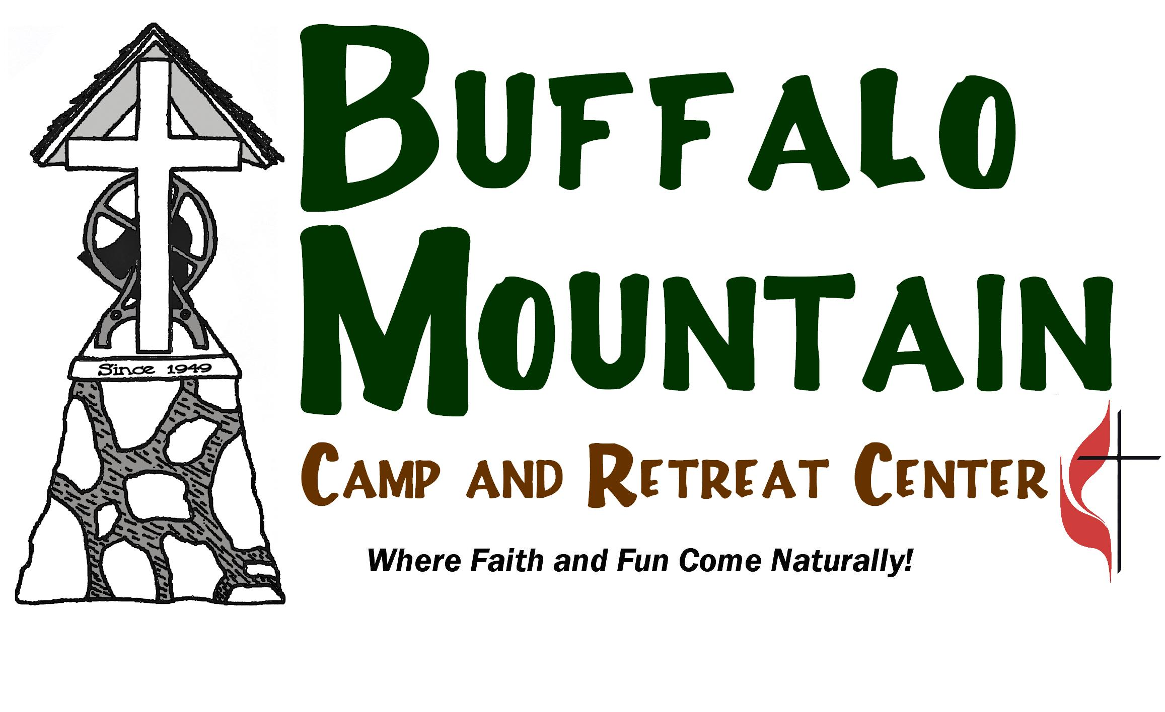

Buffalo Mountain Camp Horse Release

Release of Claims and Demands:

I understand that there are risks in horseback riding and in dealing with horses. I represent and warrant to you that _______________________is physically able to participate in horseback riding activities. I am willing for ___________________ to participate, and my signature grants my permission. You are authorized on my behalf and at my expense to take any needed measures and arrange for such medical and hospital treatment as you may deem advisable in the event of an accident. I individually and on behalf of my child expressly relieve, release and discharge Holston Conference Camping and Leisure Ministries and its affiliated Buffalo Mountain Camp, along with its personnel from liability for an accident, injury or damage resulting from my child participating in the horseback riding program offered at Millercrest Stables. I further agree to fully protect and indemnify Holston Conference Camping and Leisure Ministreis and its affiliated Buffalo Mountain Camp, along with its personnel, from any and all causes of action brought by my child. The intent and purpose of the indemnification agreement is to protect Holston Conference Camping and Leisure Ministries, and its affiliated Buffalo Mountain Camp as to any lawsuit or claim that may be filed by my child.

Signature of Parent/Gaurdian:________________________________

Date:__________________

