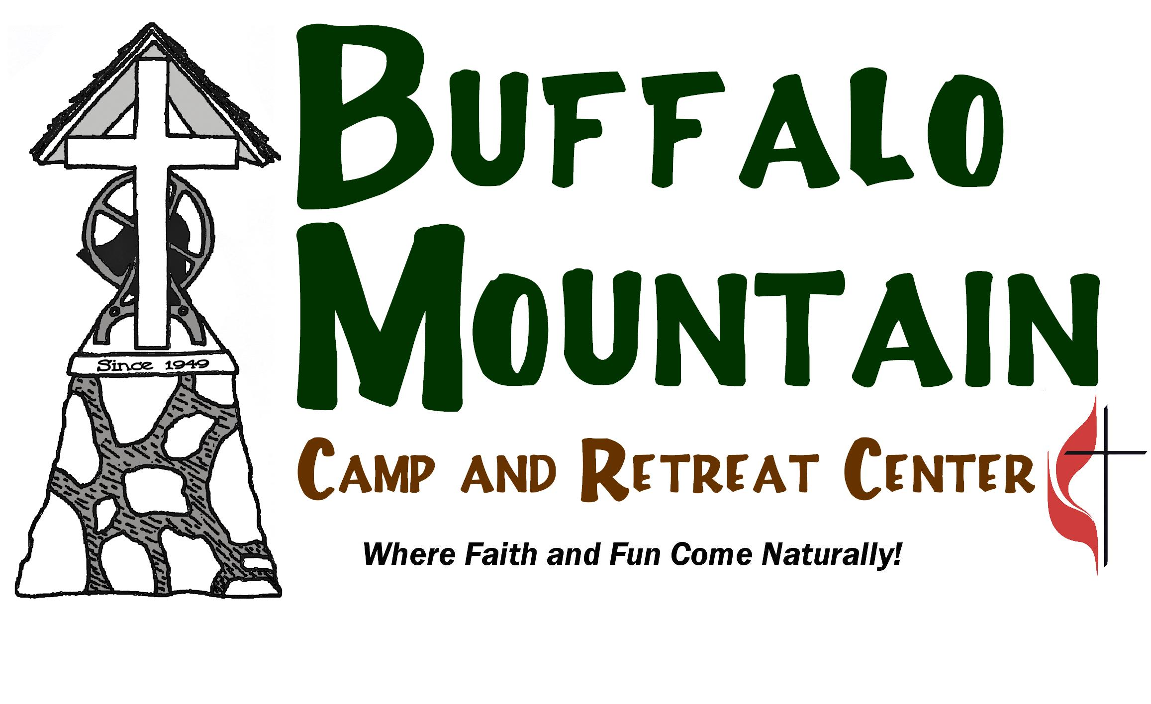
2010 GUIDE FOR CAMPERS AND FAMILIES
Buffalo Mountain Camp
Holston Conference Camp & Retreat Ministries – The United Methodist Church

Welcome to the Buffalo Mountain Camp’s GUIDE for summer campers and parents. This information will prepare you for your summer camping experience.

Buffalo Mountain Camp is a Holston Conference United Methodist Camp accredited by the American Camp Association. This guide is the beginning of your camp experience. We are already praying for you. Together we will discover God’s great love for us.

Along with this guide, you should have the following forms.

- CONFIRMATION: This information confirms the session in which you are registered, beginning and ending times, and all required forms. Please check its accuracy, and keep it for your records

- HEALTH FORM: A completed health form (3 pages) is your ticket to camp. Your parent/guardian must fill it out completely and sign. Bring your health form when you come to camp. (Please DO NOT MAIL it to the campsite.)

- RELEASES: Horseback campers and Rock Climbing and Rappelling campers will have Release Forms to complete. Please BRING releases to camp. They must be signed.

CAMPER HEALTH

Camper health is our priority. The following policies and information relate to camp health at camp. Parents/guardians will be notified if the following occur: your camper vomits, your camper develops a persistent condition (i.e. headache, nosebleed, fever, homesickness), any time a camper needs to be taken to the doctor or emergency room (Johnson City Medical Center), or if there are persistent behavioral concerns. (Abusive language or actions toward others will not be tolerated.)
All medications brought to camp must be checked in upon arrival. Both prescription and non-prescription medications must be in the original containers and clearly labeled with the camper’s name. All medications will be given according to the dispensing orders on the original container’s label unless your physician signs alternative instructions on the health form.

Part of a great experience at summer camp is to make sure that each camper is healthy when they arrive. Below are some guidelines to follow before your camper arrives at camp this summer. These guidelines will help to not only insure that your child is healthy before he or she arrives at camp, it will also help to protect the larger camp community at each of our Holston Conference Camps. If your child is sick prior to attending camp please contact the camp he or she is attending and discuss program participation options. Every attempt will be made to schedule your child in another session when their health has returned.

Assessing the Health Status of Your Camper.
Does your child have?
1. Fever (100°F or greater)? . . . . . . . . . . . o Yes o No
2. Sore throat? . . . . . . . . . . . . . . . . . . . . . o Yes o No
3. Cough? . . . . . . . . . . . . . . . . . . . . . . . . . o Yes o No

If you checked "yes" for fever AND one or two of the other symptoms, keep your child at home because of an influenza-like illness. Call our office to discuss program participation options. Current recommendation is that children remain home for seven days after symptoms start, even if the child is no longer ill. If your child is still sick after seven days, keep your child at home until well for 24 hours. If you have questions about your child's health or symptoms, call your child's healthcare provider.

If your child has been diagnosed by a healthcare provider with a different disease – such as strep – follow your healthcare provider's recommendation. Call our office to discuss program participation options.

PACKING FOR CAMP
Campers, use these lists as you pack. We suggest marking your items with your name.

FOR DAY CAMPERS: A day pack with the following – Bible, bathing suit, towel, dry clothes, an extra pair of tennis shoes for creek walking, dry socks, plastic bag for wet things, a water bottle (12 oz. Soda bottle works best), raincoat or poncho that fully covers you, water wings or life jacket if needed for the days we swim in the pool. Camp will provide your lunch and snacks.

FOR OVERNIGHT CAMPERS:

Bible Day Pack/Book Bag Sleeping Bag/Pillow
Washcloth Soap/Shampoo Toothbrush/Paste
Camp Clothes Swimming Suit Raincoat or Poncho
Towels Jacket/Sweatshirt Postcards/Stamps
Pajamas Flashlight Bag for Dirty Clothes
___ Sun Screen Long Pants
__ Closed In Shoes (couple of pairs – one of which can get wet)
Water Bottle (a clean 12 oz. plastic soda bottle with top will work)
___ Shoes for Creek Walking (may be an old pair of tennis shoes - no flip-flops)
___ Insect Repellent (lotion or mist, no aerosol)

These additional items are needed for the following sessions:

Horseback Sessions
Long pants or jeans are required for riding.
Firm, closed toe shoes with a heel for riding (no fashion or steel-toed boots).

Whitewater Kayaking Sessions
Extra swimsuit and towels
Hat, Sunglasses (with glasses keeper)
River shoes or sandals (must securely attach to and protect bottom of feet)
Long sleeved synthetic shirt such as polypropylene, capelene, polyester or fleece.
Pullover nylon jacket

Sessions Involving Rappelling or Climbing
Long, sturdy, loose fitting pants (must be able to tuck shirts in).
Rubber bands to tie back long hair.

Items not allowed at camp

Electronic Games Tobacco Weapons of any kind
Radio, CD, MP-3 Players, etc. Alcohol Pets
Cell Phones Illegal Drugs Vehicles
Food Fireworks Personal Sports Equipment
Money Firearms

Communications With Campers From Home

Phone calls from home often cause homesickness. You are welcome to send an email we can print out and send to your camper. Our campers will not have access to internet and will not be able to respond. We encourage communication the old fashioned way – letter writing. Plan ahead. You may need to mail your letter before you bring your child to camp.

Address: Buffalo Mountain Camp
241 Methodist Camp Rd.
Jonesborough, TN 37659
Attention “Camper’s Name, session name”
Or buffalomountain@hotmail.com

Phone: 423-753-6678

Directions to Camp

From the Tri-Cities:
I-26 to Johnson City to the Elizabethton exit (#24). At exit ramp light, turn left onto University Parkway. Go to second traffic light and turn left onto Cherokee Road (Hwy 67). At Cherokee Elementary School, turn left onto Lone Oak Road for 7 miles. Turn left onto Methodist Camp Road at sign.

From Knoxville, Greeneville, Morristown areas:
I-81 north to Hwy 11-E (Exit 23). Turn right onto 11-E for approximately 19.5 miles and turn right onto Hwy 107. (first light beyond Wal-Mart). Hwy 107 intersects Hwy 81 in 20.2 miles. Turn left onto Hwy 81 for .85 miles. Turn right on Hwy 67 for .9 miles. Turn right onto Arnold Road for 1.5 miles (past Cherry Grove Baptist Church). Turn left onto Dry Creek Road for 3 miles. Turn right onto Methodist Camp Road at sign.

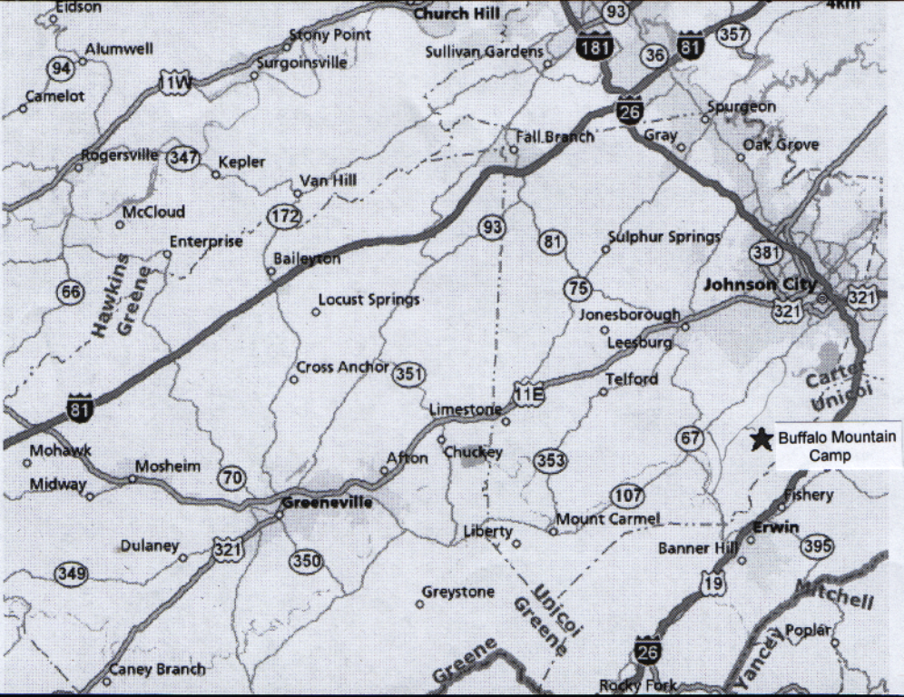
Lone Oak Rd./Dry Creek Rd.
Cherokee Rd.

A Buffalo Mountain Camp Staff Member will greet you as you enter camp and direct you to registration. See you at Camp

Jason Onks, Buffalo Mountain Camp Director 423-753-6678

