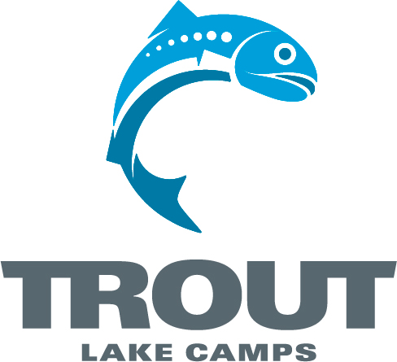
*Winter Rush
*Sample Schedule

Friday

7:00 - 9:30 Check In at Stoneridge Dining Hall
10:00 Session 1 in Chapel (Bible Teaching & Worship)
10:15 After Opening Show – Head Youth Leaders Meeting, Outside Chapel
11:15 Snack in Dinning Hall
12:00 In Cabins (Church Group Time; Questions Provided)
12:30 Lights Out

Saturday

7:00 Espresso Available
7:30 Rising Bell
8:00 Breakfast (Free Time Sign-Ups at Office)
8:30 Youth Leaders Meeting
8:30 TAG Time (Morning Devotions for Students)
9:00 Session 2 in Chapel (Bible Teaching & Worship)
10:15 Church Group Time (Questions Provided)
11:00 Morning Camp Wide Game (Tubing) / Work on Your Box Sled!
12:15 Lunch
1:00 - 5:00 Free Time Activities and Tournaments
Broomball
Indoor Climbing / Bouldering
Black Light Dodge ball
Floor Hockey & Skate Park
Polar Plunge & Sauna
Work on Your Box Sled!
5:30 Dinner
7:00 Box Sledding!
8:30 Session 3 in Chapel (Bible Teaching & Worship)
9:30 Church Group Time (Questions Provided)
10:00 Snack in Stoneridge
10:00 - 11:30 Open Barn, Tall Timbers, Black Light Dodgeball
12:00 In Cabins
12:15 Lights Out

Sunday

7:30 Espresso Available
7:45 Rising Bell
8:15 Breakfast
8:45 TAG Time (Morning Devotions for Students & Leaders)
9:00 Pack Up
9:45 Session 4 in Chapel (Bible Teaching & Worship)
11:00 Church Group Time (Questions Provided)
11:30 Lunch (Camp Store Open!)
12:00 On the Road Back Home, See You Next Time!

Winter Rush
Additional information

Things to bring:

- Signed Medical Release/Waiver Form for Participant
- Bible
- Notebook
- Pen or Pencils
- Bedding – pillow, blankets or sleeping bag, sheets (twin size)
- Toiletries, towel, pajamas, etc.
- Extra pair of gym shoes
- Closed-foot shoes
- Swimsuit , Towel, and Tube Socks (For Polar Plunge & Sauna)
- Warm Outdoor Clothing (Raincoat / Poncho / Coat depending on the weekend)
- Casual clothing (It’s a jeans and hoodie kind of weekend)
- Many activities will be outside, so bring warm clothing (and an extra set “just in case”)
- Cash to purchase extra treats and camp souvenirs

What to expect:

- To meet new friends and grow closer with your youth leaders, youth group, and Jesus Christ!
- To have lots of fun through a variety of camp-exclusive activities and games! – You won’t be able to do everything in just one weekend at Trout!
- To engage in great Bible-centered messages, relevant worship, and discussion
- To make lasting memories!
- To enjoy God in his creation!

*Recreation Activities for the Weekend:

- Climbing Wall
- Bouldering Wall
- Ping Pong
- Riflery
- Tubing Hill!
- Laser Tag
- Black Light Dodge Ball
- Wiffle ball
- Broomball Tourney
- Floor Hockey
- Indoor Skate Park
- Crate Stacking
- Air Hockey
- Volleyball
- Board Games
- Carpet Ball
- The Barn
-Polar Plunge Lake Jump & Sauna

*Activities subject to change

